**Phptravels’s Workflow**

The workflow of this website is similar to that of other e-commerce applications. First of all, we access the main page of phptravels. On that page, we are presented with the services provided by phptravels. They are hotels booking, flight schedules, tours, and visas as functional component. There is also a section for user account settings on the top right of the website, along with language and currency selection. From the non-functional component, users are presented with blog pages, offers, and company information.

After a successful login, the user is able to see a recap of the bookings that have been made, their wallet balance, and other important information about his account. Regarding phptravels's homepage, users can access one of the four services provided. Then do a search about the feature, fill in their personal data and complete the payment. Phptravels supports various payment options, including Paypal, Bank transfer, Paylater, and others. On the non-functional side, the blog, offers, and company tabs provide additional information that may be useful. A rough outline of the workflow from the phptravels.net website can be seen below.

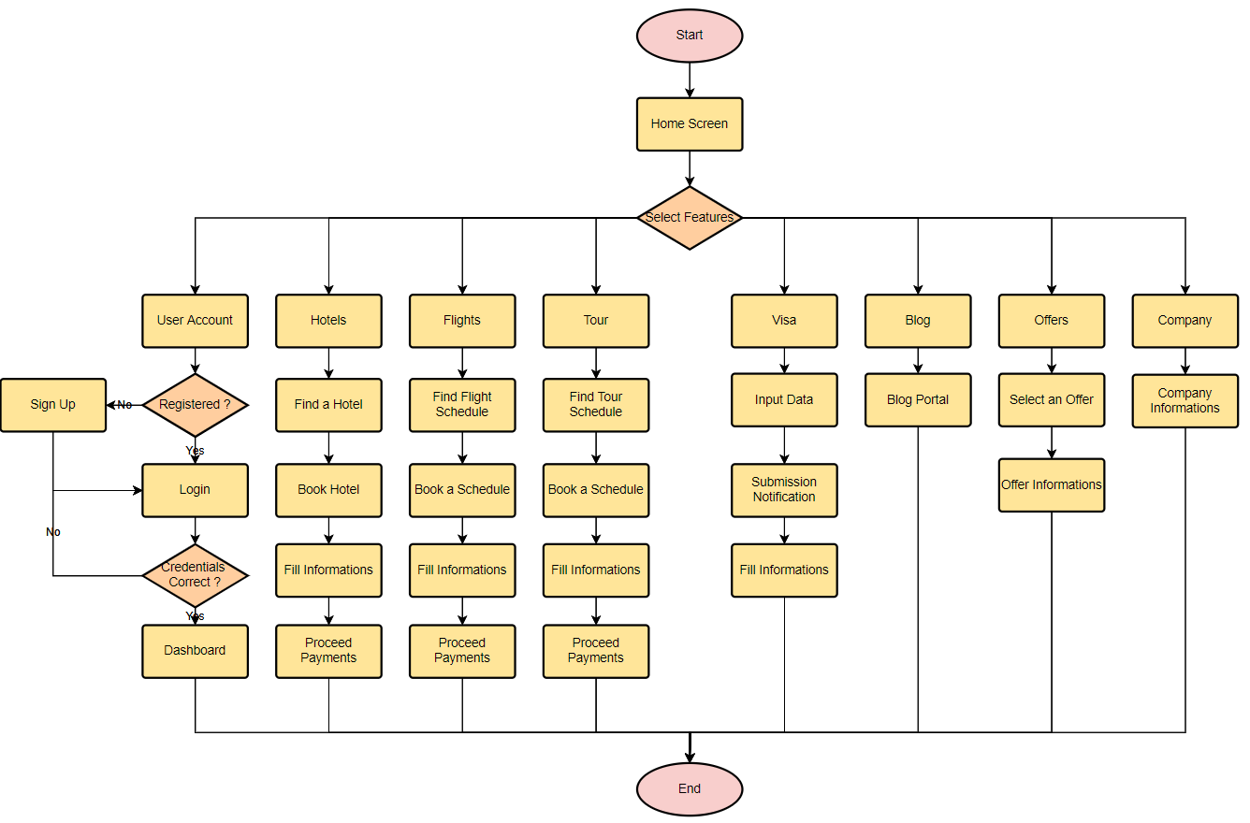

**User Experience**

From my perspective, Phptravels has poor UX standards. For example, on the main page, important points of Phptravels advantages are split at the bottom and top of the website (You'll never roam alone, Travel to anytime, anywhere at the top; and Secure Payments, Cancel Policy at the bottom), where these points should be emphasized on top or the bottom of the website. On the home screen page, there is also some image content that fails to load. The Phptravels own logo is also not showing as the main app icon at the top left. Instead, they show a car manufacturer logo. The content in the header and footer is not well planned. In the header section, the signup and login features for each role can only be shown as 1 button and unified. The color in the footer is the same as the background color of the content (white) and does not match the subscribe section. There is also an error while opening some links in the footer section.

Features provided by Phptravels are quite complete. We can search for a wide range of hotels, flights, tours, and visas on the main page as well as their specialized tabs. The waiting screen when a search is conducted is not bad, but it is better if the search time can be reduced and disable this feature. However, the three services provided have similar flaws. After trying to do a search, the provided filters are not able to provide good user satisfaction. For example, the price sorting feature doesn't exist yet (Min to Max, Max to Min, etc.). Then the available "Price range" only provides a price range in the form of a slider. Users cannot input the exact price range. The price slider also does not adjust to the various currencies used (USD, JPY, etc.). Then when the user changes the currency, it will be returned to the main page, so the process must be repeated from the beginning and resulting in process/data loss. Users were also unable to select an item When pressing the center of the provided cards banner.

In the main menu of hotel services, featured hotels cannot display a portion of the overview image in some of the offered hotels. This greatly worsens the face of phptravels from the user's eyes. In addition, in some hotels, broken image links were found when the “more photos” function was used. However, other information such as hotel location, facilities, and other information are well displayed, with easy access at the top section of the page. The room choices, facilities, and prices displayed are in accordance with the user's needs, with the drawback that there is a lack of sample photos for the rooms that the user will book.

On the flight schedule searching page, we find the flight route we are looking for. But when no schedule is found, phptravels show 2 different notifications. They are “Oops, no Match”, and “404 Error”. This may result in user confusion regarding the problem that causes this error. Phptravels should display only 1 correct error message. However, the one trip and round-trip features provide quite a lot of information and clearly explain the flight route.

In service tours, when accessing one of the tours information, information is only displayed using text, it is recommended that the route is visualized via google maps or other forms of route visualization. When processing payment, the biggest flow of phptravels is not displaying the total cost charged to the user for this feature.

Also, there is no detailed explanation of the procedures and special conditions for applying for a visa. Furthermore, the Blog feature is should be dedicated to a special page or website that is intended to provide more information. The Offers tab provides many offers, but the content can only be clicked on the text, not the item/image. There is also no filter in the offers section to distinguish hotel, flight, or tour services promotions. For the explanation of the Company part, I haven't gotten a good impression of the contents of the content. The explanation is only in the form of text without suitable images.

When we log into the system as a user, we see a pretty decent dashboard. The dashboard provides important information such as wallet balance, bookings status, and reviews. The drawback is that there is no option to update the user's profile photo.

Note:

The Review or Feedback process is done when the Phptravels.net website is working correctly. On 6/9/2021, starting at 06:00 WIB to 14:00 WIB, the website is down and script building is interrupted.

Automation Test Script can be seen at https://github.com/faiznc/Software_QA_Test.